**Data structures and Algorithms Assignment 1 – Text Compression: Huffman Coding**

**Weighting 15%**

Issue Date: 1/11/2010

Due Date: 28/11/2010 – 5 pm (Moodle upload of files + Hardcopy, see later for details).

**Introduction**

Huffman coding is a scheme that assigns variable-length bit-codes (binary strings) to characters, such that the lengths of the codes depend on the frequencies of the characters in a typical message. As a result, encoded messages take less space (as compared to fixed-length encoding such as ASCII or UNICODE) since the letters that appear more frequently are assigned shorter codes. This is performed by first building a Huffman coding **Tree** based on a given set of frequencies. From the tree, bit-codes for each character are determined and then used to encode a message. The tree is also used to decode an encoded message as it provides a way to determine which bit sequences translate back to a character. (See the text passage at the end of the assignment for more details).

You are to implement a Huffman coding system using the frequency table given below (this is also in a text file on my student share called LetterCount.txt in folder Assignment 1). Your final solution should be able to encode any message that uses the characters of the english alphabet or decode any bit sequence to the corresponding characters. There are three main parts to the system, *generating the huffman tree, encoding and decoding*.

**Frequency Table**

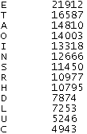 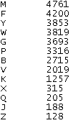

**Part 1: Generating the Huffman Tree (40 marks)**

Here you are required to generate a binary tree (Huffman tree) representing the bit-codes of each character in the alphabet. The characters that occur more frequently will have shorter bit codes than those occurring less frequently. Traversing the huffman tree from root to leaf should reveal the bit-code of the characters, where a left branch encodes a 0 (zero) and a right branch a 1. In this way, the leaves of the tree will represent the characters in our alphabet and the paths from the root to the leaves will reveal the binary codes for the characters. See the tutorial at the end of the document for an example on how to create a Huffman tree from a frequency table. You should reuse ADTs that you have seen in class where you can. For example you could extend the BinaryTree class to create a HuffmanTree class. You could also use an ADT List to represent the frequency table above. Some changes or extensions may be needed to the Node classes, e.g. Node.java, TreeNode.java but these should become apparent during your analysis of the problem.

**Part 2: Encode (20 marks)**

This part of the assignment will involve generating the binary code for a message from the alphabet. This will be obtained by traversing the Huffman tree from the root to the leaf for each character in the message. There are a number of approaches that could be taken to this part. One might be to find the leaf node in the tree for a particular character and then back track from there to the root recording zero’s and one’s depending on whether you encounter a left or right branch. You would also need to reverse the code at the end as you went backwards up the tree. Display also the compression ratio for the encoded message by assuming that the fixed length representation for each character is 7 bits (the ASCII standard).

**Part 3: Decode (20 marks)**

This part of the assignment involves taking a binary string (the bit code) and regenerating the character message from the Huffman tree. To do this you will need to use the binary code to guide you down the right branches (remember, 0 for a left branch and 1 for a right branch) until you encounter a leaf and therefor e a character in the message.

**Part 4: Program Interface (20 marks)**

The interface for this program should be quite straightforward and resemble something like the following (with a bit more colour and dazzle ☺):

Text Area for output message after decoding or bitcode after encoding

Text Area for input message for encoding or bitcode for decoding

Decode button

Encode button

**You will receive marks for:**

1. All work attempted and submitted.
2. The quality of your solution design and your report describing this in detail.
3. The quality of your code and in-program documentation (comments).
4. You will receive marks for a bug-free, fully tested, application.
5. The quality of the test data.
6. The quality and professionalism of the design of the user graphical user interface. Ideally, this should be user friendly, realistic and have a well-designed Java look and feel while not permitting the entry of erroneous data.
7. Innovation and creativity in your deign and solution.

**You are required to deliver:**

1. A Java application including **source code and .class file**
2. A **description of your program design** stating the design problems that you needed to address and how you surmounted them. For each of these, state the design problem and them your solution.
3. **Screen shots** illustrating test cases
4. A professionally written and word-processed **report** that contains all of the above.
5. Signed copy of the plagiarism form

**Note:**

* The paper report is to be handed up no later than the designated **due date** – **Fri, 28th November 2010**. (Letter Box B8 in E-block or to office E020).
* The electronic copy of the report along with the assignment source code (.java), class files is to be uploaded to Moodle before 5pm on 28th November 2010. (all files in one zip file please).
* This assignment is worth **15%** of the available marks. **Late assignments** will incur a loss of 3% of marks per day late.

### Academic Honesty

*You may help each other freely to complete labs, as the purpose of the labs is to increase your understanding. This, however, this does not mean that someone else can do your lab work for you, or that you can do someone else’s work for them. Any work that you submit for continuous assessment or assignments must contain a significant contribution by you. Any help you receive from someone must be acknowledged in the work submitted. Failure to acknowledge the source of a significant idea or approach is considered plagiarism and not allowed. Academic dishonesty will be dealt with severely. At a minimum, you will receive a mark of zero for the assignment.*

Extract from Data Structures and Algorithms in Java, Goodrich and Tamassia.

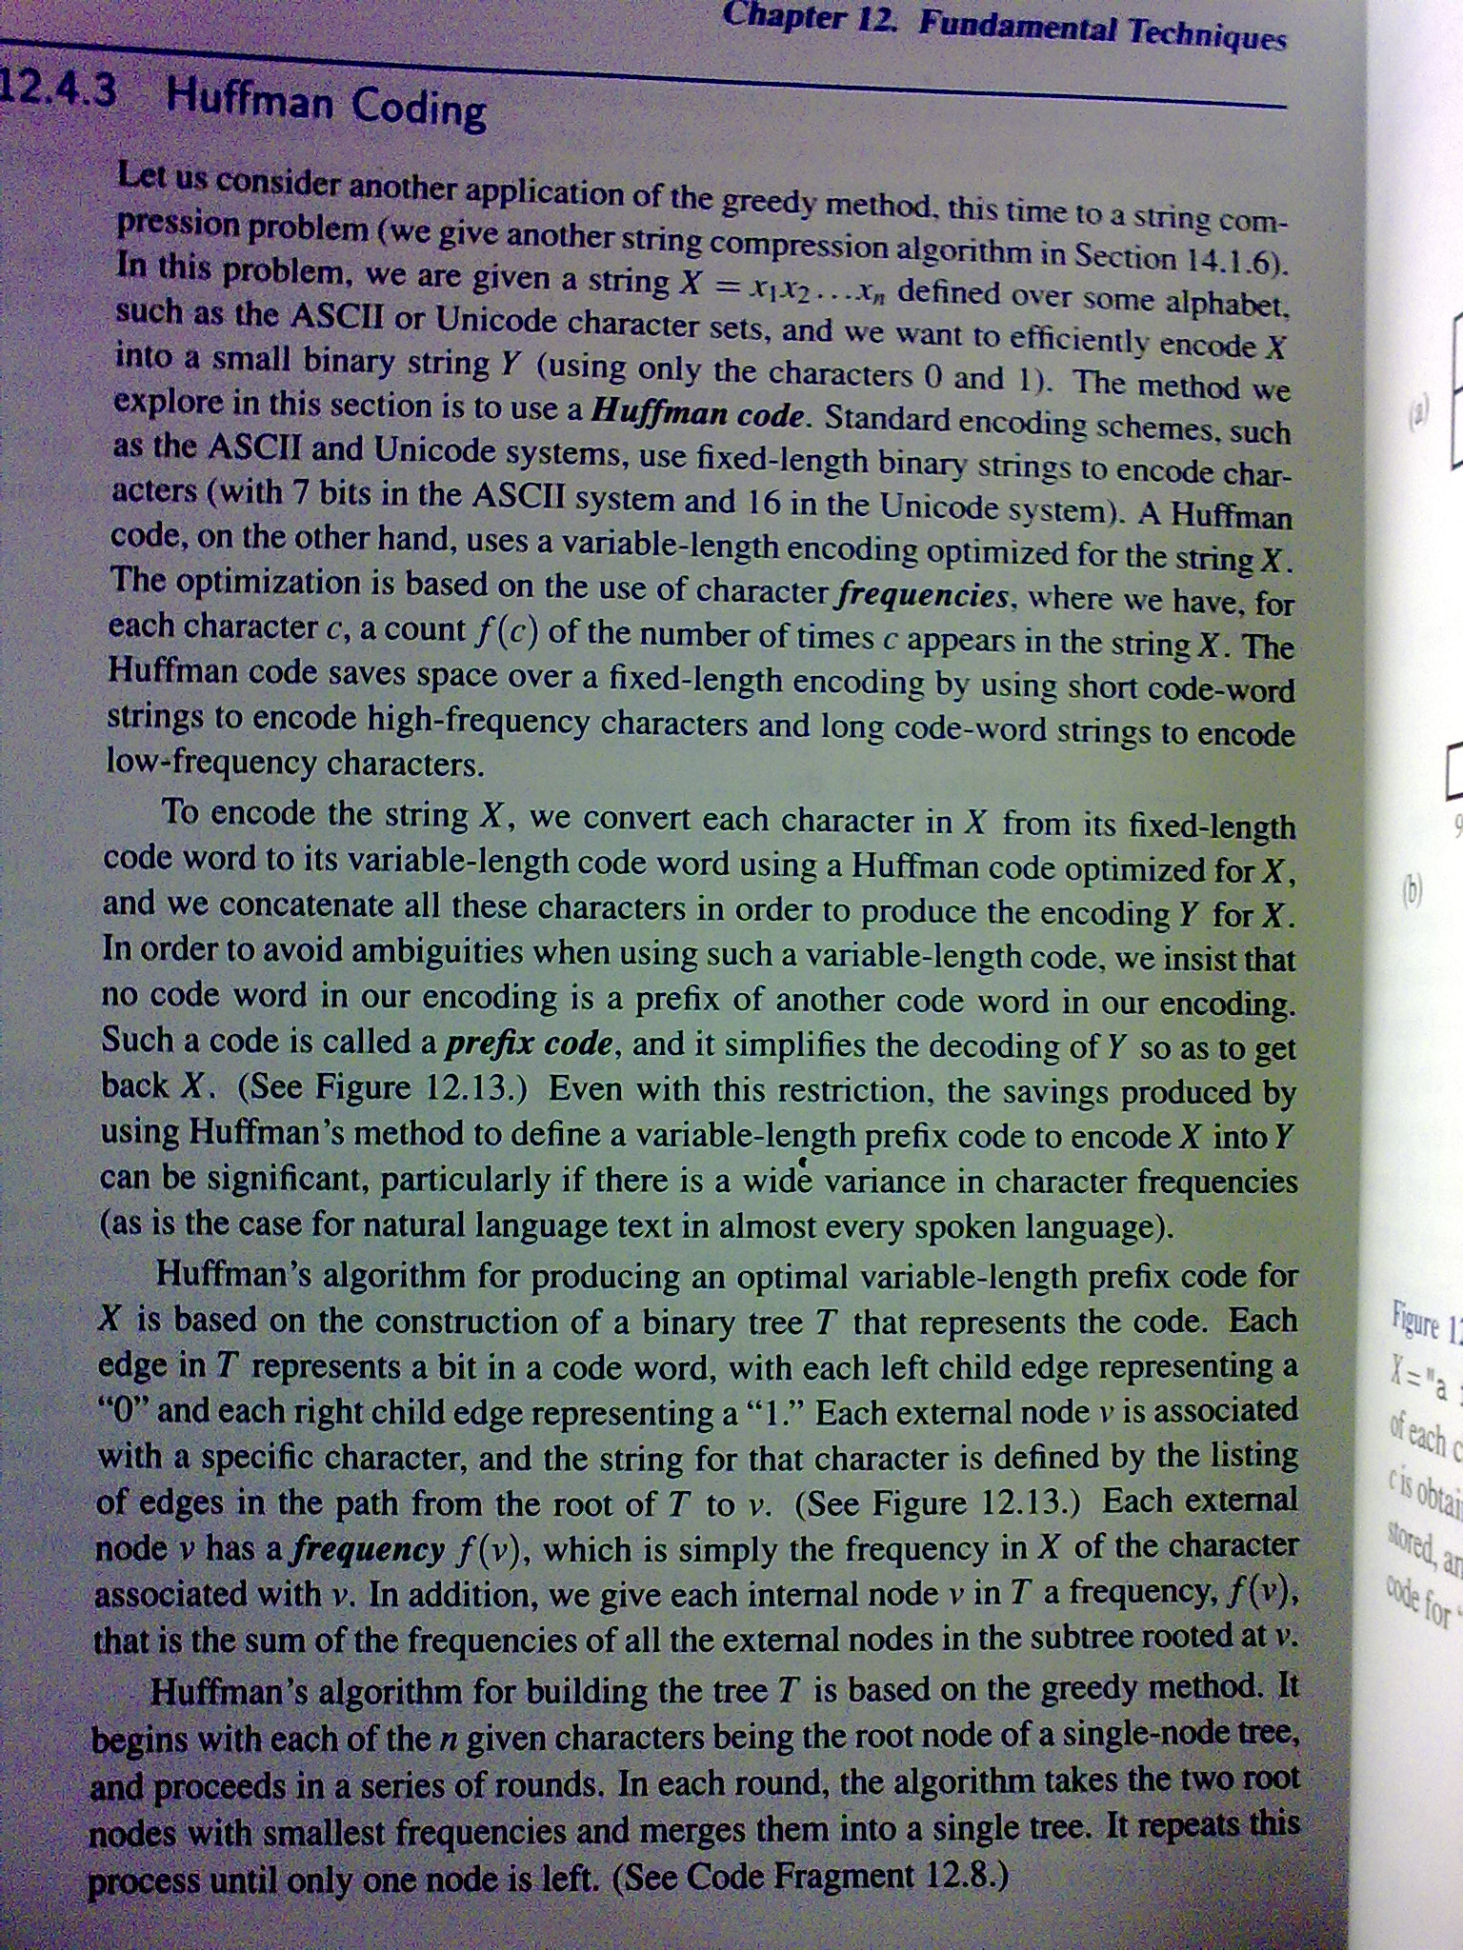

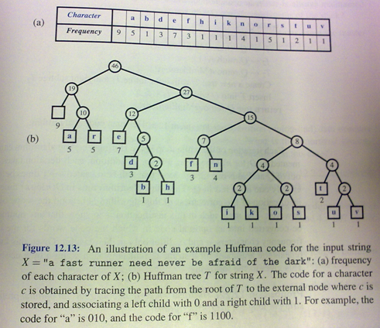

**A quick tutorial on generating a huffman tree – siggraph.org**

Let’s say you have a set of numbers and their frequency of use and want to create a huffman encoding for them:

**FREQUENCY** VALUES of **ALPHABET**

--------- -----

5 1

7 2

10 3

15 4

20 5

45 6

Creating a huffman tree is simple. Sort this list by frequency and make the two-lowest elements into leaves, creating a parent node with a frequency that is the sum of the two lower element's frequencies:

12:*

/ \

5:1 7:2

The two elements are removed from the list and the new parent node, with frequency 12, is inserted into the list by frequency. So now the list, sorted by frequency, is:

10:3

12:*

15:4

20:5

45:6

You then repeat the loop, combining the two lowest elements. This results in:

22:*

/ \

10:3 12:*

/ \

5:1 7:2

and the list is now:

15:4

20:5

22:*

45:6

You repeat until there is only one element left in the list.

35:*

/ \

15:4 20:5

22:*

35:*

45:6

57:*

___/ \___

/ \

22:* 35:*

/ \ / \

10:3 12:* 15:4 20:5

/ \

5:1 7:2

45:6

57:*

102:*

__________________/ \__

/ \

57:* 45:6

___/ \___

/ \

22:* 35:*

/ \ / \

10:3 12:* 15:4 20:5

/ \

5:1 7:2

Now the list is just one element containing 102:*, you are done.

This element becomes the root of your binary huffman tree. To generate a huffman code you traverse the tree to the value you want, outputing a **0** every time you take a lefthand branch, and a **1** every time you take a righthand branch. (normally you traverse the tree backwards from the code you want and build the binary huffman encoding string backwards as well, since the *first* bit must start from the top).

**Example**: The encoding for the value **4** (15:4) is **010**. The encoding for the value **6** (45:6) is **1**

Decoding a huffman encoding is just as easy : as you read bits in from your input stream you traverse the tree beginning at the root, taking the left hand path if you read a **0** and the right hand path if you read a **1**. When you hit a leaf, you have found the code.